Riphah International University

Gulberg greens Campus

Submitted by : Mahnoor Ahmed
Sap id : 80207
Submitted to : Mam Nayab Khalid
Lab # 07

Task no.1
1. Make Person (method introduce()) and Student (method study()). Call both on one Student object.

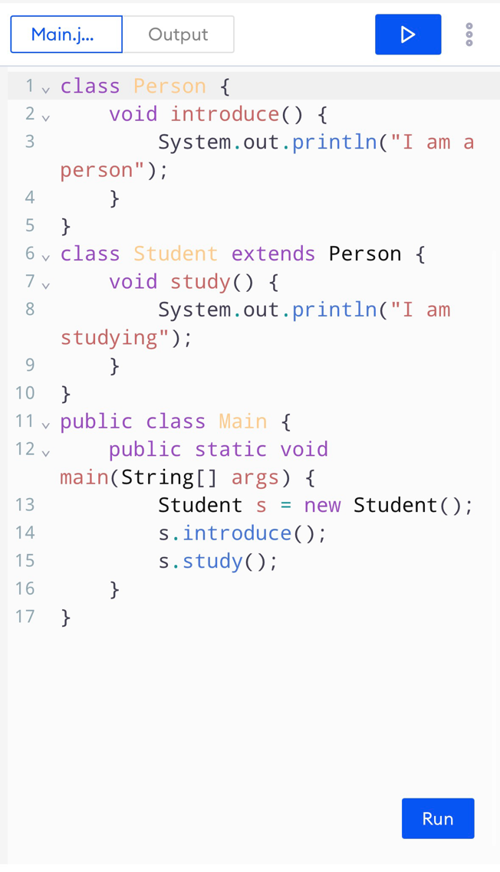
Code :

Result :
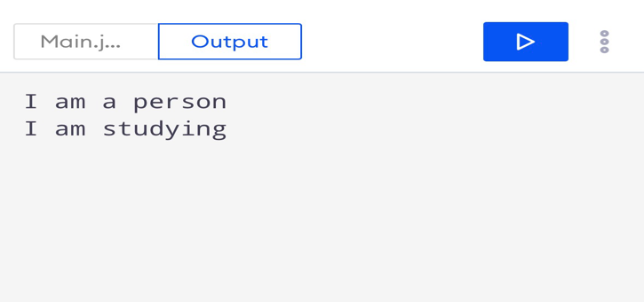
Task no.2
2. build Grandfather → Father → Son, each with one method that prints its own name. Call all three on one Son object.

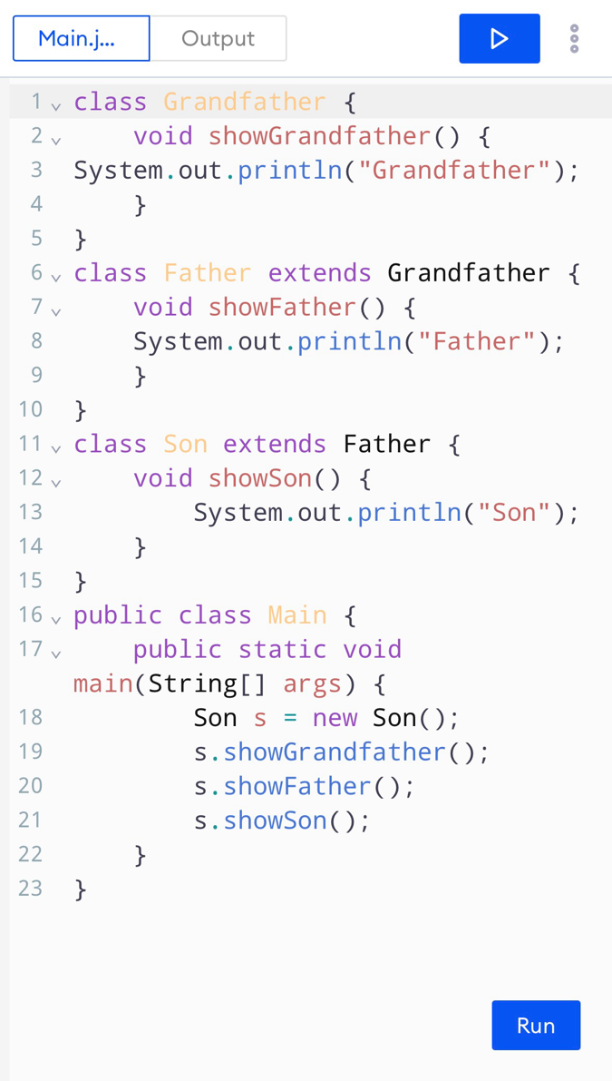
Code :

Result:
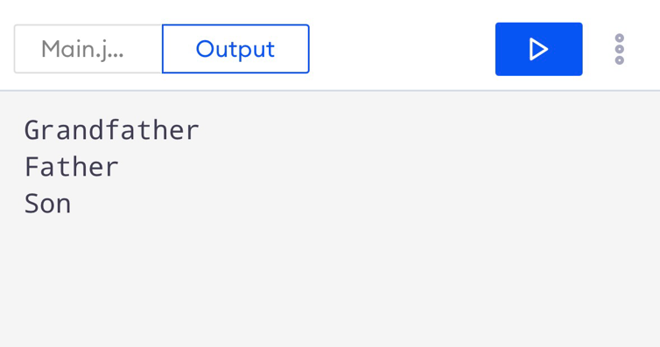
Task no.3
3. make Employee (with showName()), then Manager and Engineer, each with its own showRole().
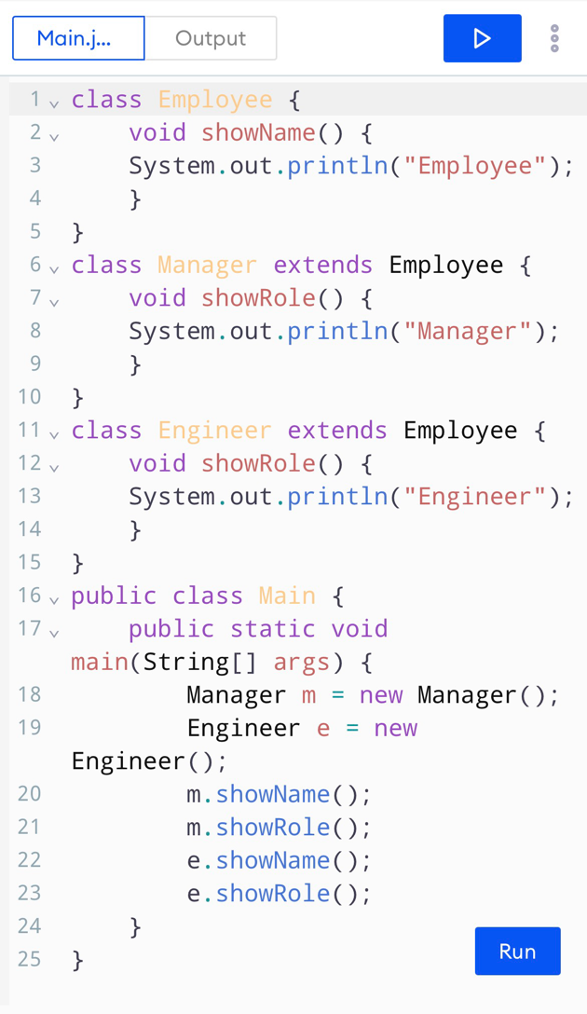
Code :
Result:
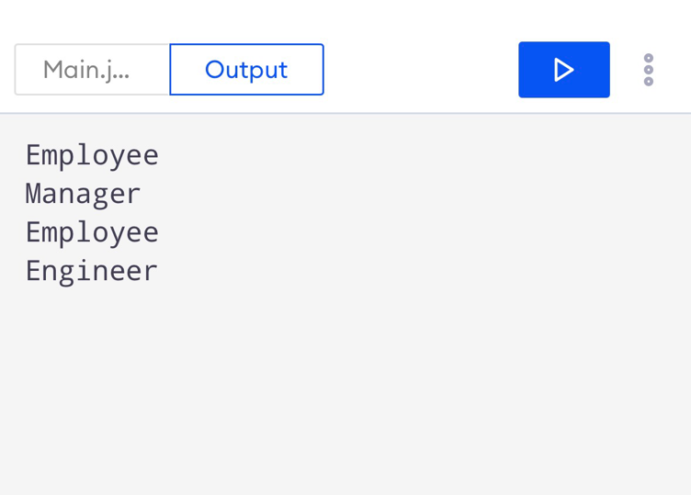
Task no.4
4. make interfaces Printer (print()) and Scanner (scan()), then a class AllInOnethat implements both.
Code :
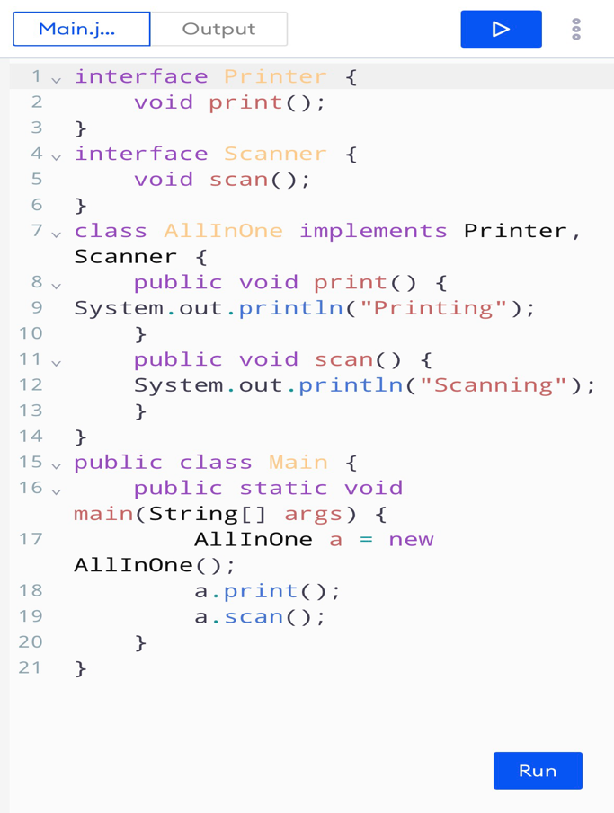

Result:
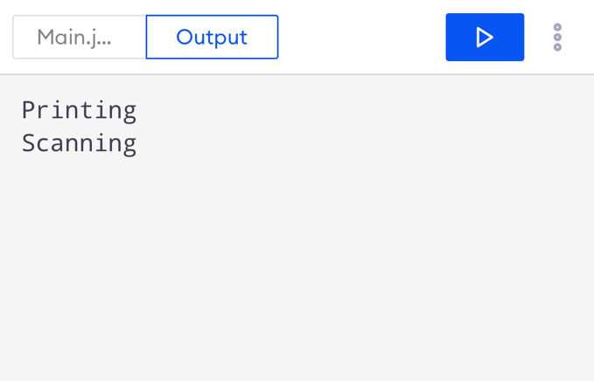
Task no .05
create an interface Shape with void draw();. Make Circle and Squareimplement it with @Override. Store both in a Shape[] array and call draw() in a loop.
Code :
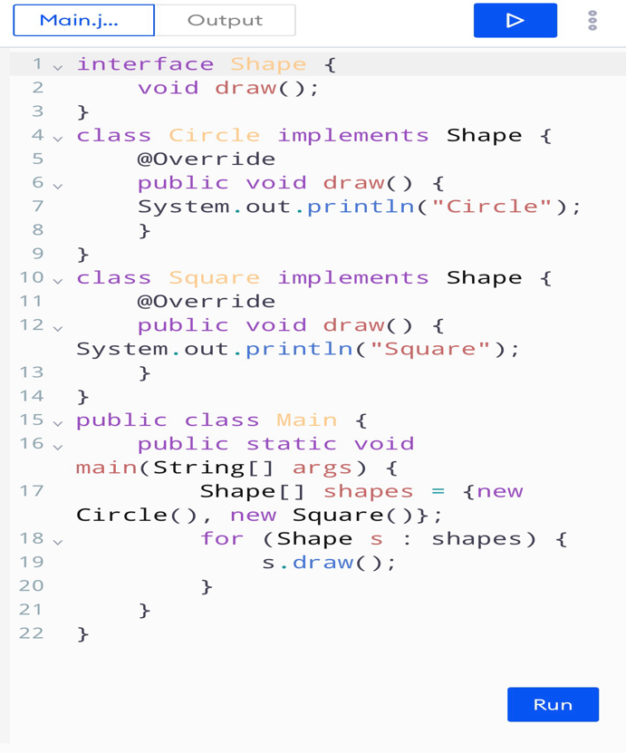

Result:
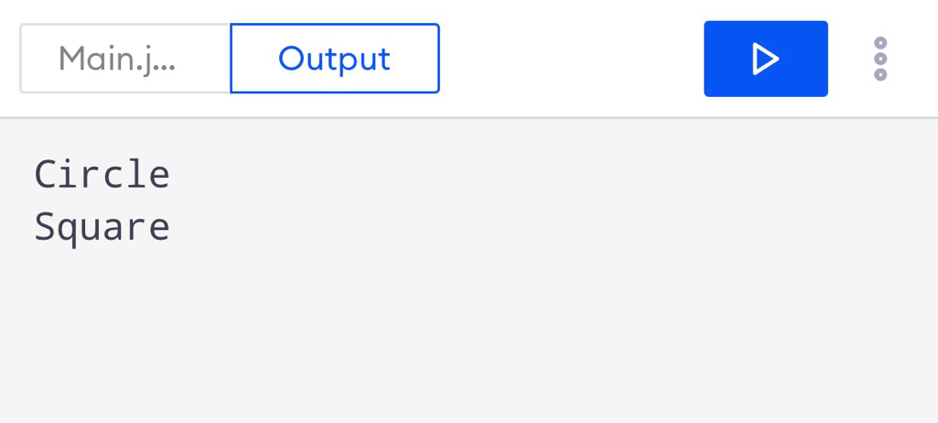
Task no .06
make Employee with a constructor taking name. Make Manager call super(name) and also print a bonus line.
Code:
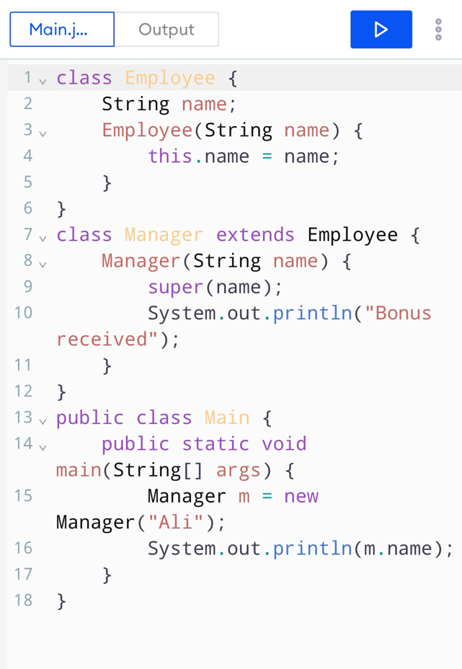

Result:

Task no .7
7. Predict the output (do not run it first):

class A { A() { System.out.print("A "); } }
class B extends A { B() { System.out.print("B "); } }
class C extends B { C() { System.out.print("C "); } }
public class Main {
public static void main(String[] args) { new C(); }
}

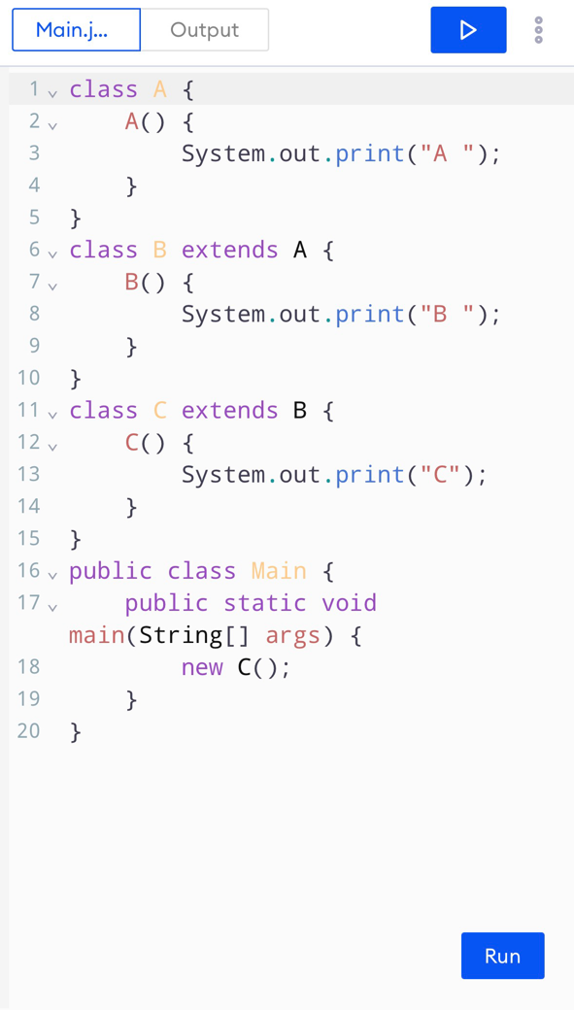
Code :

Result:


